Step 1: download git, create account on github

Step 2. Create a new folder in your pc and do the right click

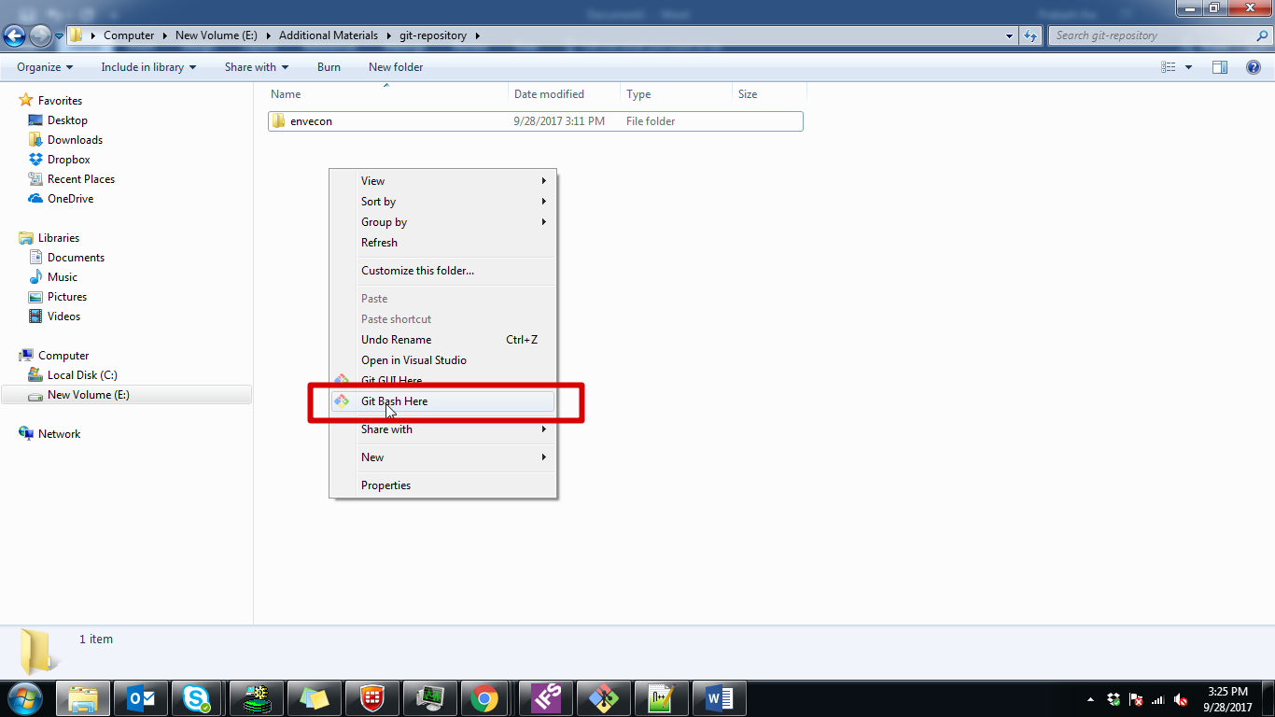

Step 3: click on that and write command:

Git clone path_of_your_repository

For example: git clone <https://github.com/prakashjha1956/envecon.git>

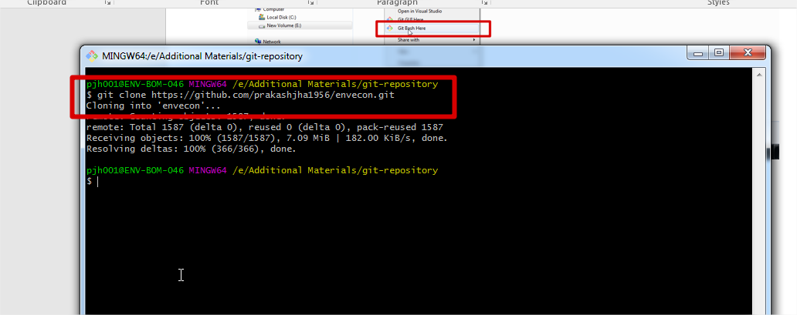

Step 4: now you downloaded all files and right click on get gui here

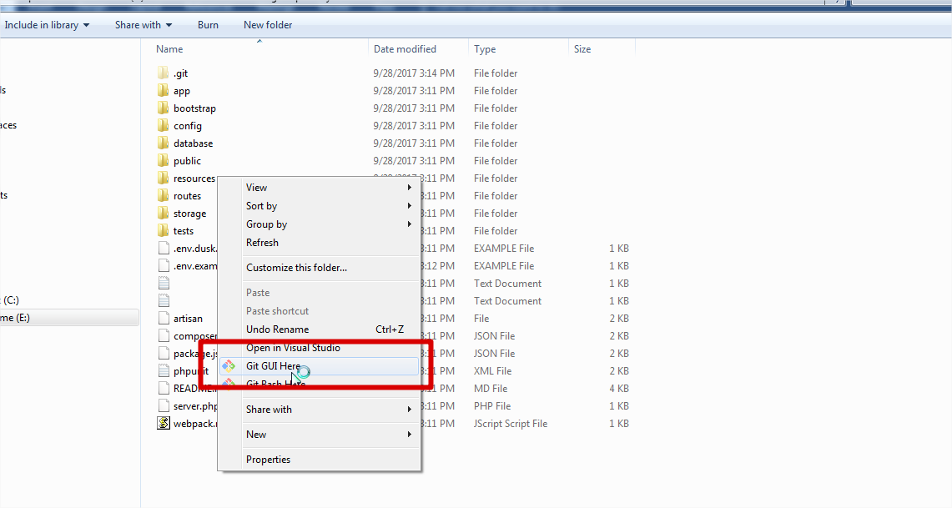

Step 5: use the option to commit your files in repository

Rescan , stage to commit and commit

